**Aim:**

This is a Number Plate Recognition process. The aim is to extract the Number Plate from image of vehicle provided in the given format (.jpg, .png, etc). This is usually helpful for catching people from running away by jumping signals or violating traffic rules.

**Requirements:**

To run the following process, we require:

1. Matlab Software
2. Image of vehicle with number plate on it in given format
3. A little knowledge on Image Processing
4. Coding in Matlab

**Process:**

1. We must first write the code given below in Matlab software.
2. **clc**
3. **clear all;**
4. **close all;**
5. **imtool close all;**
6. **workspace;**
7. **[FileName,PathName] = uigetfile('*.jpg;*.png;*.gif;*.tif','Select a image');**
8. **I=imread(strcat(PathName,FileName));**
9. **figure(1);**
10. **imshow(I);**
11. **Igray = rgb2gray(I);**
12. **[rows cols] = size(Igray);**
13. **Idilate = Igray;**
14. **for i = 1:rows**
15. **for j = 2:cols-1**
16. **temp = max(Igray(i,j-1), Igray(i,j));**
17. **Idilate(i,j) = max(temp, Igray(i,j+1));**
18. **end**
19. **end**
20. **I = Idilate;**
21. **figure(2);**
22. **imshow(Igray);**
23. **figure(3);**
24. **title('Dilated Image')**
25. **imshow(Idilate);**
26. **figure(4);**
27. **imshow(I);**
28. **difference = 0;**
29. **sum = 0;**
30. **total_sum = 0;**
31. **difference = uint32(difference);**
32. **disp('Processing Edges Horizontally...');**
33. **max_horz = 0;**
34. **maximum = 0;**
35. **for i = 2:cols**
36. **sum = 0;**
37. **for j = 2:rows**
38. **if(I(j, i) > I(j-1, i))**
39. **difference = uint32(I(j, i) - I(j-1, i));**
40. **else**
41. **difference = uint32(I(j-1, i) - I(j, i));**
42. **end**
43. **if(difference > 20)**
44. **sum = sum + difference;**
45. **end**
46. **end**
47. **horz1(i) = sum;**
48. **if(sum > maximum)**
49. **max_horz = i;**
50. **maximum = sum;**
51. **end**
52. **total_sum = total_sum + sum;**
53. **end**
54. **average = total_sum / cols;**
55. **figure(5);**
56. **subplot(3,1,1);**
57. **plot (horz1);**
58. **title('Horizontal Edge Processing Histogram');**
59. **xlabel('Column Number ->');**
60. **ylabel('Difference ->');**
61. **sum = 0;**
62. **horz = horz1;**
63. **for i = 21:(cols-21)**
64. **sum = 0;**
65. **for j = (i-20):(i+20)**
66. **sum = sum + horz1(j);**
67. **end**
68. **horz(i) = sum / 41;**
69. **end**
70. **subplot(3,1,2);**
71. **plot (horz);**
72. **title('Histogram after passing through Low Pass Filter');**
73. **xlabel('Column Number ->');**
74. **ylabel('Difference ->');**
75. **disp('Filter out Horizontal Histogram...');**
76. **for i = 1:cols**
77. **if(horz(i) < average)**
78. **horz(i) = 0;**
79. **for j = 1:rows**
80. **I(j, i) = 0;**
81. **end**
82. **end**
83. **end**
84. **subplot(3,1,3);**
85. **plot (horz);**
86. **title('Histogram after Filtering');**
87. **xlabel('Column Number ->');**
88. **ylabel('Difference ->');**
89. **difference = 0;**
90. **total_sum = 0;**
91. **difference = uint32(difference);**
92. **disp('Processing Edges Vertically...');**
93. **maximum = 0;**
94. **max_vert = 0;**
95. **for i = 2:rows**
96. **sum = 0;**
97. **for j = 2:cols %cols**
98. **if(I(i, j) > I(i, j-1))**
99. **difference = uint32(I(i, j) - I(i, j-1));**
100. **end**
101. **if(I(i, j) <= I(i, j-1))**
102. **difference = uint32(I(i, j-1) - I(i, j));**
103. **end**
104. **if(difference > 20)**
105. **sum = sum + difference;**
106. **end**
107. **end**
108. **vert1(i) = sum;**
109. **if(sum > maximum)**
110. **max_vert = i;**
111. **maximum = sum;**
112. **end**
113. **total_sum = total_sum + sum;**
114. **end**
115. **average = total_sum / rows;**
116. **figure(6)**
117. **subplot(3,1,1);**
118. **plot (vert1);**
119. **title('Vertical Edge Processing Histogram');**
120. **xlabel('Row Number ->');**
121. **ylabel('Difference ->');**
122. **disp('Passing Vertical Histogram through Low Pass Filter...');**
123. **sum = 0;**
124. **vert = vert1;**
125. **for i = 21:(rows-21)**
126. **sum = 0;**
127. **for j = (i-20):(i+20)**
129. **sum = sum + vert1(j);**
130. **end**
131. **vert(i) = sum / 41;**
132. **end**
133. **subplot(3,1,2);**
134. **plot (vert);**
135. **title('Histogram after passing through Low Pass Filter');**
136. **xlabel('Row Number ->');**
137. **ylabel('Difference ->');**
138. **disp('Filter out Vertical Histogram...');**
139. **for i = 1:rows if(vert(i) < average) vert(i) = 0;**
140. **for j = 1:cols I(i, j) = 0;**
141. **end**
142. **end**
143. **end**
144. **subplot(3,1,3);**
145. **plot (vert);**
146. **title('Histogram after Filtering');**
147. **xlabel('Row Number ->');**
148. **ylabel('Difference ->');**
149. **figure(7),**
150. **imshow(I);**
151. **j = 1;**
152. **for i = 2:cols-2**
153. **if(horz(i) ~= 0 && horz(i-1) == 0 && horz(i+1) == 0)**
154. **column(j) = i;**
155. **column(j+1) = i;**
156. **j = j + 2;**
157. **elseif((horz(i) ~= 0 && horz(i-1) == 0) || (horz(i) ~= 0 && horz(i+1) == 0))**
158. **column(j) = i;**
159. **j = j+1;**
160. **end**
161. **end**
162. **j = 1;**
163. **for i = 2:rows-2**
164. **if(vert(i) ~= 0 && vert(i-1) == 0 && vert(i+1) == 0)**
165. **row(j) = i;**
167. **row(j+1) =i;**
168. **j = j +2;**
169. **elseif((vert(i) ~= 0 && vert(i-1) == 0) || (vert(i) ~= 0 && vert(i+1) == 0))**
170. **row(j) = i;**
171. **j = j+1;**
172. **end**
173. **end**
174. **[temp column_size] = size (column);**
175. **if(mod(column_size, 2))**
176. **column(column_size+1) = cols;**
177. **end**
178. **[temp row_size] = size (row);**
179. **if(mod(row_size, 2))**
180. **row(row_size+1) = rows;**
181. **end**
182. **for i = 1:2:row_size**
183. **for j = 1:2:column_size**
184. **if(~((max_horz >= column(j) && max_horz <= column(j+1)) && (max_vert >=row(i) && max_vert <= row(i+1))))**
185. **for m = row(i):row(i+1)**
186. **for n = column(j):column(j+1)**
187. **I(m, n) = 0;**
188. **end**
189. **end**
190. **end**
191. **end**
192. **end**
193. **figure(8),**
194. **imshow(I);**
195. **imshow(I);**

2. After running the above code, run it.

3. Then it will ask you to input the image of the vehicle in given format.

4. Once that is done, it will give 8 images as output.

5. The 8th image is the one with the number plate.

**Analysis:**

The 8 images that were obtained were:

1. The original image that was uploaded by the user.

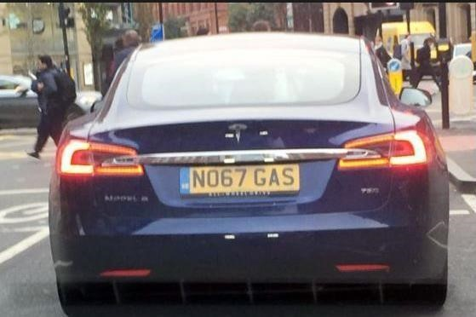

1. The same image in Black and White.

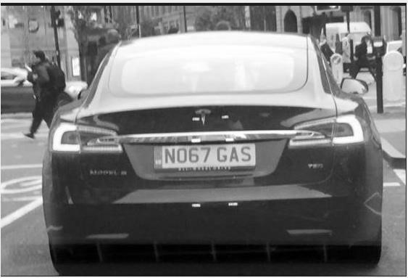

1. It is the dilated image of the 2nd image.

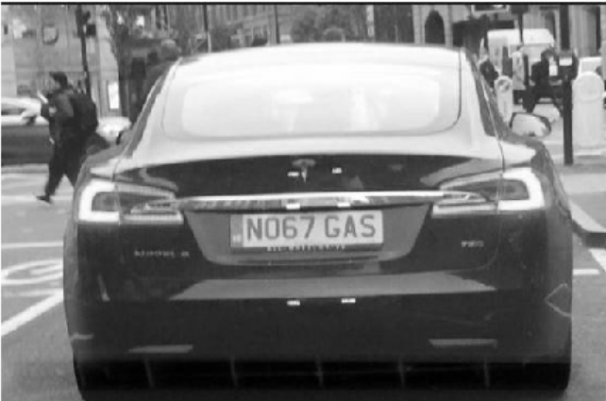

1. It shows the dilated image again with a reformation.

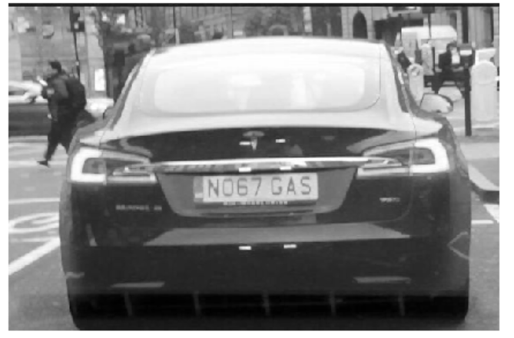

1. This shows 3 graphs after Processing Edges Horizontally through filter:
2. **Horizontal Edge Processing Histogram**
3. **Histogram after passing through Low Pass Filter**
4. **Histogram after Filtering**

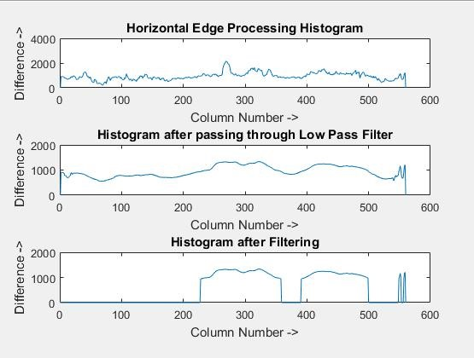

1. This shows 3 graphs after Processing Edges Vertically through filter:
2. **Vertical Edge Processing Histogram**
3. **Histogram after passing through Low Pass Filter**
4. **Histogram after Filtering**

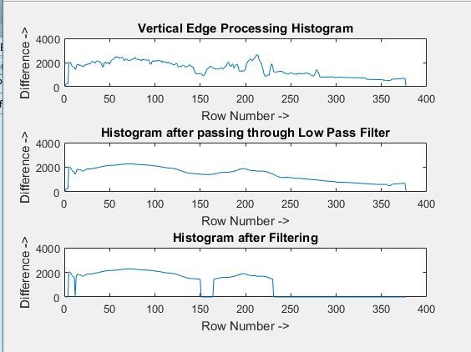

1. Shows the respective image in block structures after removing parts which do not contain the parts of the number plate. It removes parts of the image which do not contain regions of the number plate.

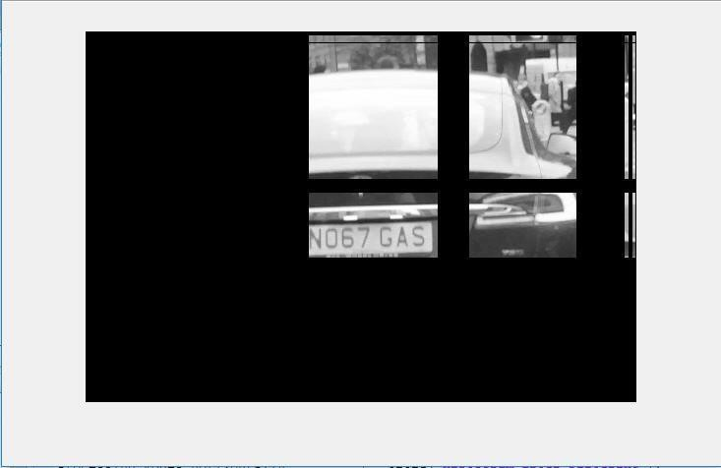

1. This is the final image of the number plate. This is the result of our process.

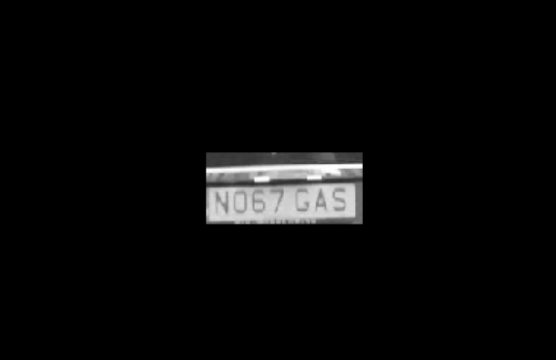

**Conclusion:**

This process is based on principles of machine learning. We are using